**Goal**

To determine what tools, application and microservices are being implemented on Front-end of other AEM websites, and possible solution for TechData.com.

**Data Sources**

The companies were found using 2 sources.

1. <https://www.featuredcustomers.com/vendor/adobe-experience-manager/case-studies> a website that is a customer reference platform for B2B business software and services. It helps potential B2B buyers to search and discover business software and services through vendor validated customer reference content such as customer testimonials, success stories, case studies, and customer videos.
2. <https://whatcms.org/c/Adobe-Experience-Manager>

Analytic Tools

The companies were initially analyzed using application tools and then the source code manually reviewed to verify the quality of the analysis.

Analytics Browser tools

1. <https://www.wappalyzer.com/>

Programmatic access to technographic data. The **Wappalyzer** APIs provide instant access to website technology stacks, contact details and social media profiles.

1. <https://www.whatruns.com/>

What Runs shows you pretty much everything that powers a website. Web apps they pay for, CDN they are hosted on, how they track their visitors, WordPress plugins, fonts – you name it!

1. Browser Inspector, every modern web browser includes a powerful suite of developer tools. These tools do a range of things, from inspecting currently loaded HTML, CSS and JavaScript to showing which assets the page has requested and how long they took to load.

**Figure 1. List of Companies and Website links using AEM.**

|  |  |
| --- | --- |
| Samsung  <https://www.samsung.com/us/> | Salesforce  <https://www.salesforce.com/> |
| HP  <https://www8.hp.com/us/en/home.html> | CDW  <https://www.cdw.com/> |
| LinkedIn  <https://www.linkedin.com/> | FedEx  <https://www.fedex.com/en-us/home.html> |
| Chase  <https://www.chase.com/> | McDonald’s  <https://www.mcdonalds.com/us/en-us.html> |
| Dell  <https://www.delltechnologies.com/en-us/index.html> | Visa  <https://usa.visa.com/> |
| Deloitte  <https://www2.deloitte.com/us/en.html> | Mastercard  <https://www.mastercard.us/en-us.html> |
| KAO  <https://www.kao.com/global/en/worldwide.html> | Australia Tourism  <https://www.australia.com/en-us> |
| Scandinavian Airlines  <https://www.flysas.com/en/> | Adobe  <https://www.adobe.com/> |

**Analysis of CSS Frameworks**

**Figure2. Pie Chart of 16 companies using Bootstrap, Custom Bootstrap and Custom Frameworks**

**Figure 3. Table showing companies and CSS Framework.**

|  |  |
| --- | --- |
| COMPANY | CSS FRAMEWORK |
| Samsung­ | Custom |
| Salesforce | Custom Bootstrap |
| HP | Custom |
| CDW | Custom |
| LinkedIn | Bootstrap |
| FedEx | Bootstrap |
| Chase | Bootstrap |
| McDonalds | Bootstrap |
| Dell | Custom |
| Visa | Custom Bootstrap |
| Deloitte | Custom |
| Mastercard | Custom |
| KAO | Custom |
| Australia Tourism | Custom |
| Scandinavian Airlines | Custom |
| Adobe | Custom |

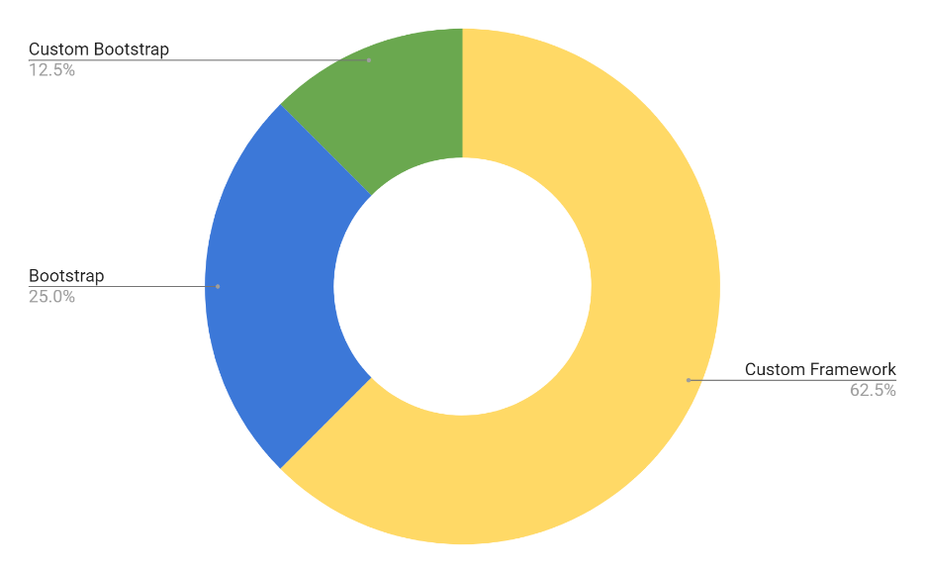

Note:

Custom are references to a CSS Framework built specifically for the company.

Custom Bootstrap are references to CSS Framework customized built on bootstrap foundation.

Bootstrap out the box CSS framework.

**Data review**

Based Figure 2. And Figure 3. We can see an emerging trend; 27.5 % were using a Bootstrap/ custom Bootstrap or 62.5 % built a custom framework as their solution. Using the data, we can see 3 solutions for CSS emerge.

1. Build a Custom Framework.
2. Build a Custom Framework using Bootstrap.
3. Use Bootstrap out of the box.

**Analysis CCS Framework solutions for 3 of the 16 companies that offer similar services to Tech Data.**

**Figure 4. Table showing CSS Framework solution for CDW, DELL and HP.**

**Data Review**

Based on Figure 4. Companies that offer similar products and solutions chose to create a custom framework.

Technologies used by CDW, DELL and HP

**CDW**  **Dell Technologies**

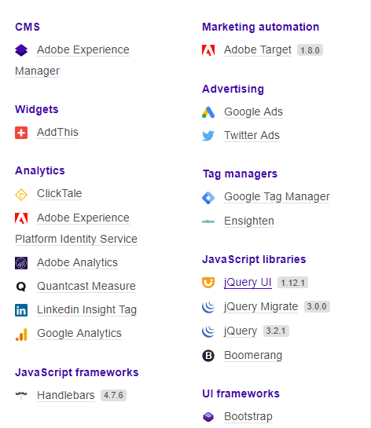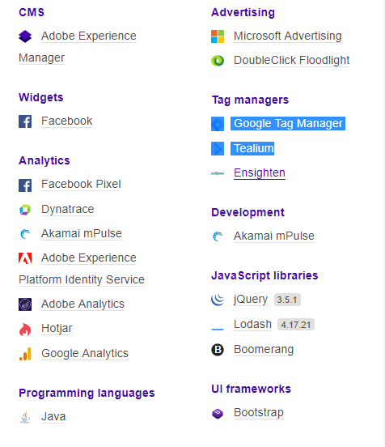<https://www.cdw.com/><https://www.delltechnologies.com/en-us/index.html>

**HP**

<https://www8.hp.com/us/en/home.html>

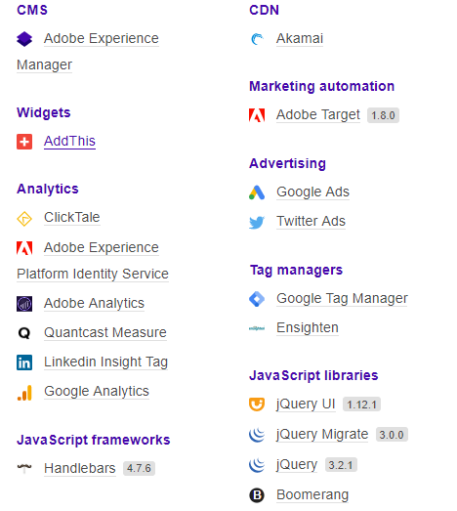

**Please not that source code reviews indicated that neither used Bootstrap but instead created a Custom CSS Framework with similar class codes to Bootstrap.**